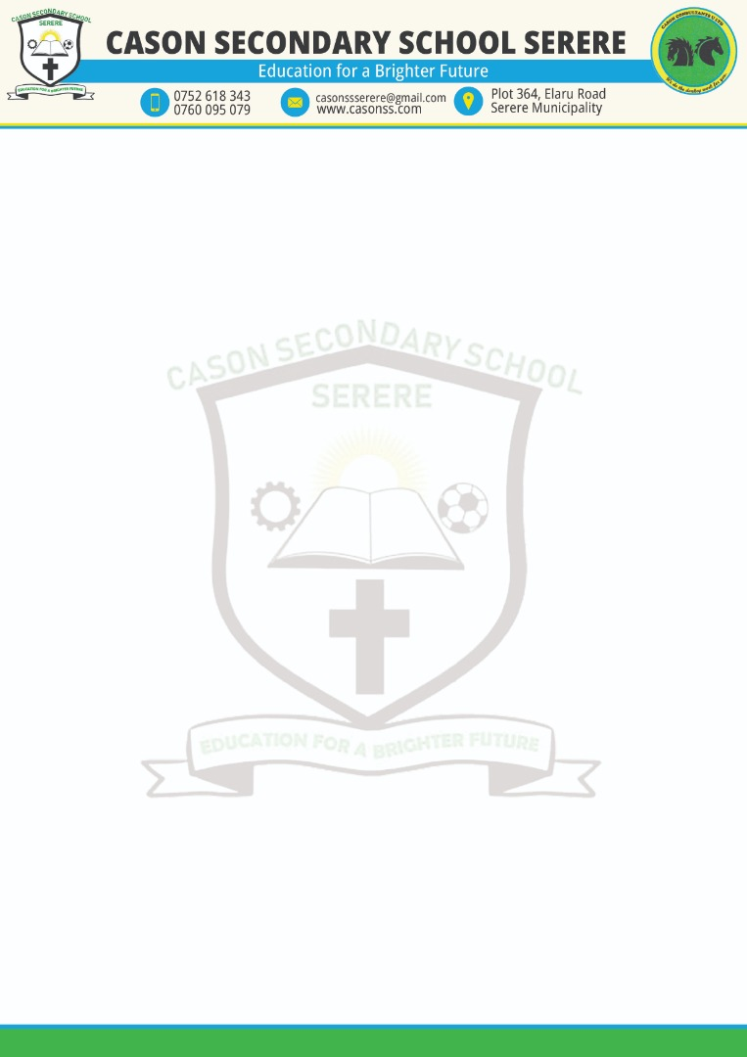

20/10/2022

JOB ADVERT

CASON SECONDARY SCHOOL SERERE IS INVITING APPLICATIONS FROM QUALIFIED SECONDARY SCHOOL TEACHERS:

**Qualification and requirements:**

1. Must be a graduate teacher from a recognized university,
2. Must be registered or licensed with Ministry of Education and sport,
3. Teaching experience in an added advantage but not mandatory,
4. Certified academic(degree) documents.

**How to apply**

Applications with supporting documents listed above should be delivered to CASON SECONDARY SCHOOL SERERE not later than Friday October 28, 2022 at 4:00PM.

Applications should be delivered from 8:00AM to 5:00PM Monday to Saturday

Copies of the application may be emailed to casonssserere@gmail.

**Location of the school**

The school is located behind Serere District headquarters along Elaru road that joins Soroti road to Ngora road

**Help line**

For any assistance please call any of the telephone lines bellow

Tel: 0752618343

0760095079

0785898887